HADOOP

- Data Ingestion:
Create a directory in HDFS and transfer the banking dataset from the local system to the HDFS directory.
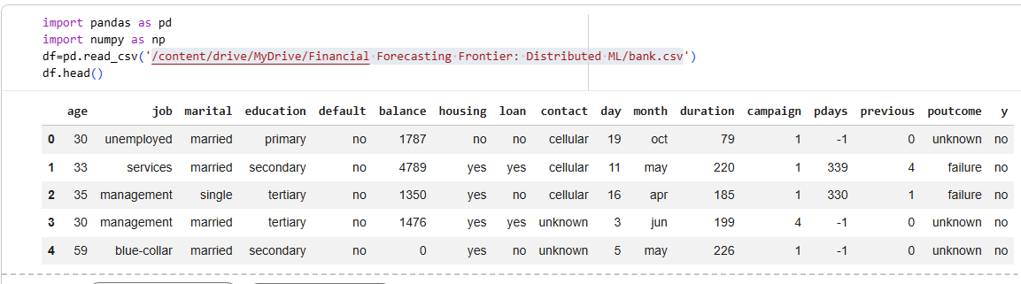
- Data Transformation with MapReduce:
Write a MapReduce program in Python that calculates the average account balance for each job type.

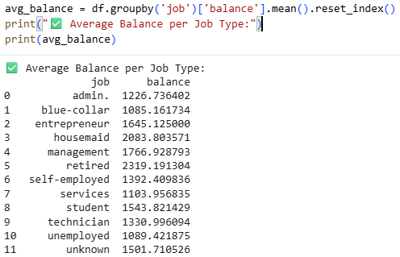

Write another MapReduce program that counts the number of individuals with and without a housing loan in each education category.

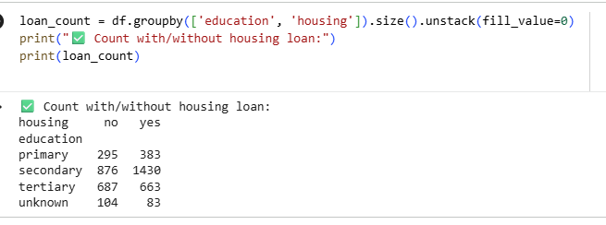

Perform a MapReduce job to determine the number of clients contacted in each month and their subscription status to term deposits ('y' column).
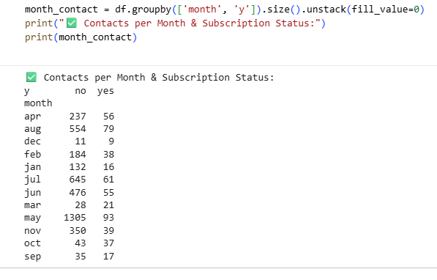

- Data Analysis with MapReduce:
Analyze the average duration of contact (in seconds) per campaign outcome ('poutcome').

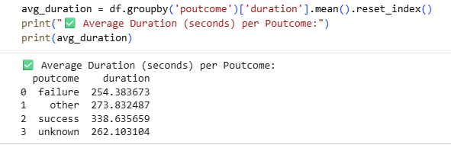

Examine the relationship between the age of clients and their balance, and present findings in a summarized form.
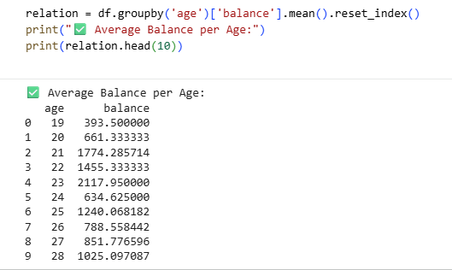

HIVE
- Data Ingestion and Table Creation:
Create a Hive database named banking_data.
  - Define and create a Hive table client_info with appropriate data types for the bank.csv dataset.
  - Load the data from the bank.csv file into the client_info table.

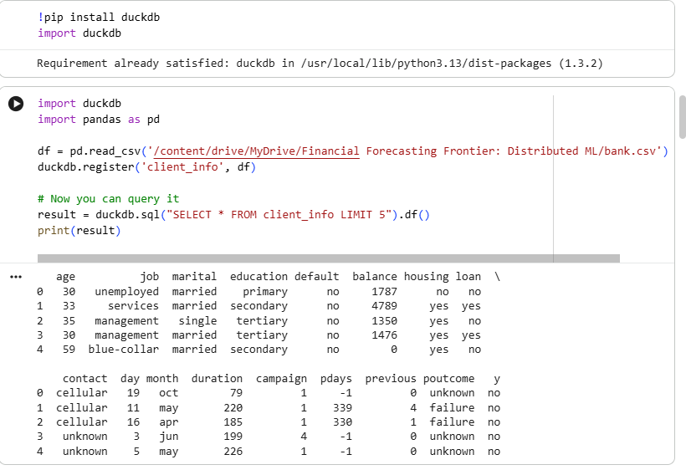

- Basic Data Exploration:
Write a HiveQL query to count the total number of clients in the dataset.
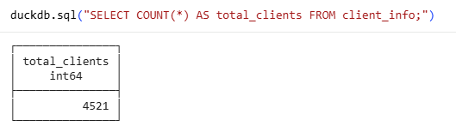

Display the first 10 rows of the dataset.
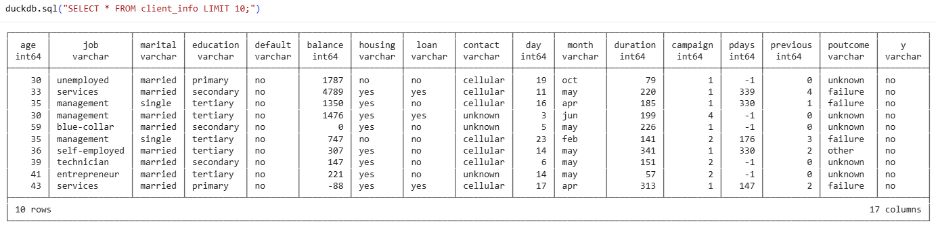

- Data Filtering and Sorting:
Retrieve all records of clients who are married and have a personal loan.

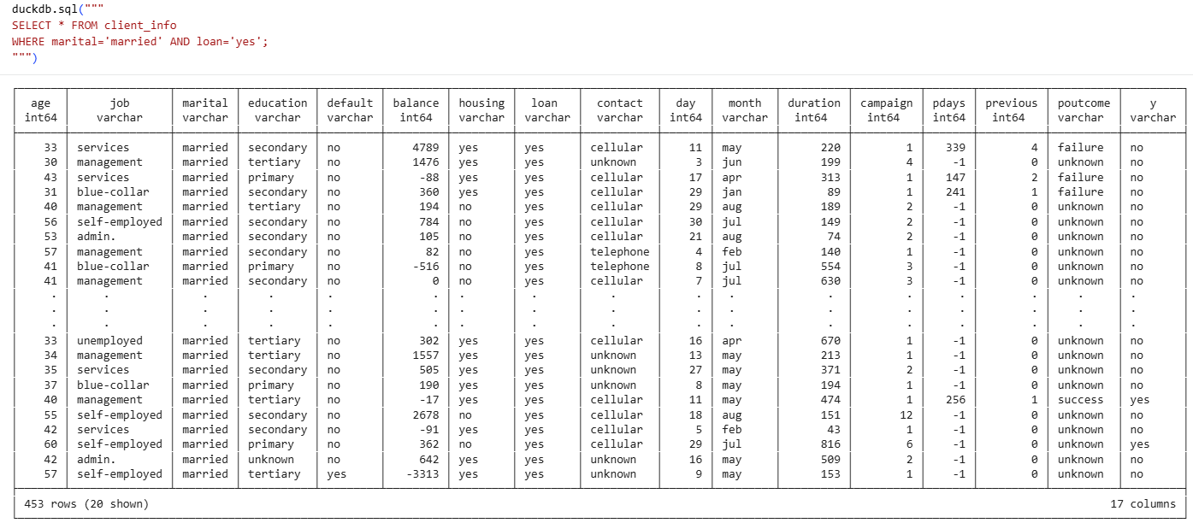

List the top 10 clients with the highest balance, displaying their job, marital status, and balance.

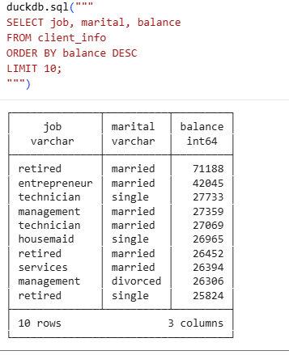

- Data Aggregation and Grouping:
Calculate the average age of clients for each job category.

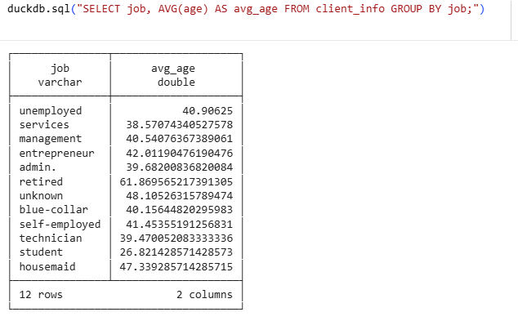

Find the total number of clients for each education level who have defaulted on credit.
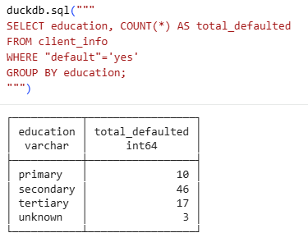

- Complex Queries for Insights:
Identify the top 5 job categories with the highest average balance and the percentage of clients in each of these job categories who have subscribed to a term deposit.

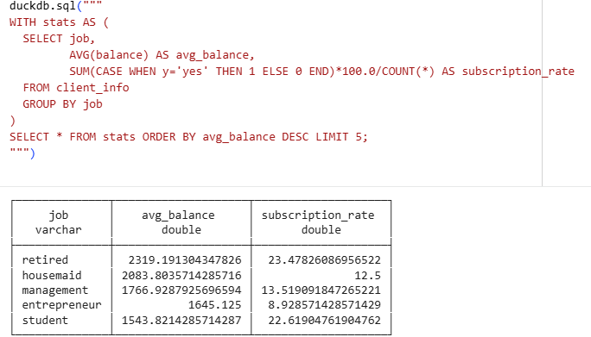

Determine the month with the highest number of contacts and the success rate of the campaign in that month (percentage of clients who subscribed to a term deposit).
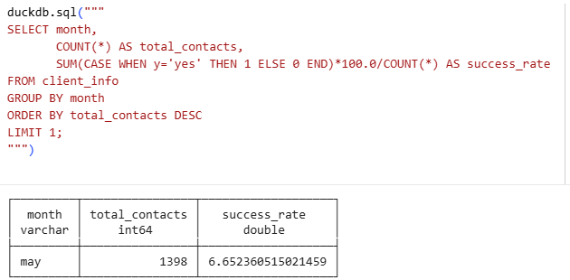

- Correlation Analysis:
Calculate the correlation between age and balance for the clients.

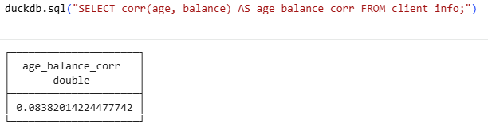

- Trend Analysis:
Analyze the year-over-year trend in the number of clients contacted.

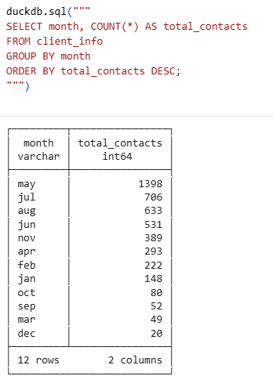

- Anomaly Detection:
Identify any unusual patterns in the average yearly balance across different education levels.

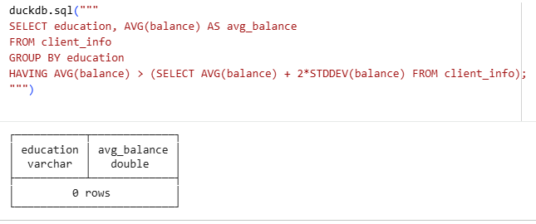

- Advanced Analysis:
Analyze the impact of previous campaign outcomes (poutcome) on the current campaign's success. Calculate the subscription rate (to term deposits) for each poutcome category.

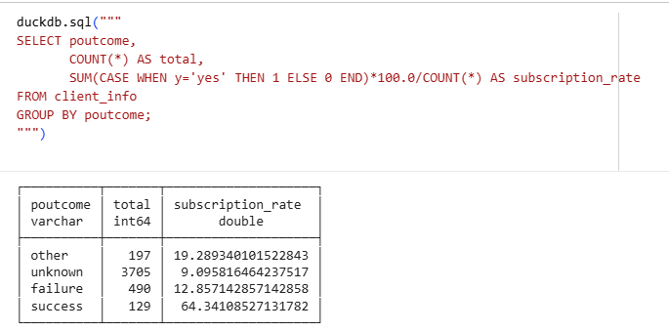

Compare the average contact duration for clients who subscribed and who did not subscribe to a term deposit.
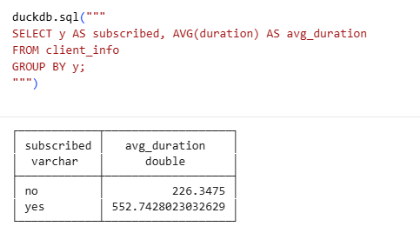
Submission Guidelines:
- Make a copy of this doc file.
- Perform the analysis in your local system using Hadoop and Hive and provide screenshots of both the code and the output under each question.
- Upload the doc file with other files and submit it in the submission dashboard.

